18.64:
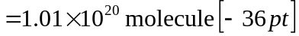

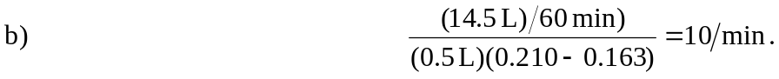

c) The density of the air has decreased by a factor of 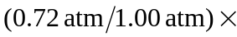 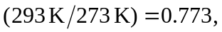 and so the respiration rate must increase by a factor of 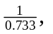 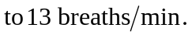If the breathing rate is not increased, one would experience “shortness of breath.”

